States of Matter

1. Below is a heating curve for a pure substance. It shows how the temperature rises over time, when the substance is heated until it melts, then boils.

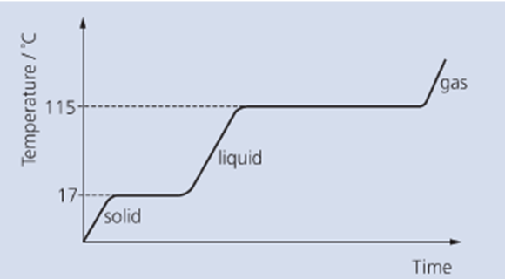

a) What is the melting point of the substance? ……………………………………

b) What happens to the temperature while the substance changes state? ……………………………
…………………………………………………………………………….…………………………………….
…………………………………………………………………………….…………………………………….

c) The graph shows that the substance takes longer to boil than to melt. Suggest a reason for this.
…………………………………………………………………………….…………………………………….
…………………………………………………………………………….…………………………………….
…………………………………………………………………………….…………………………………….

d) How can you tell that the substance is not water? ……………………………………………..

e) What is the state of this substance at room temperature (25ºC)? ……………………………

f) Carefully sketch a cooling curve for this substance

g) Describe the change in arrangement, movement and energy of the particles as they change state from solid to liquid.

Arrangement:……………………………….…………………………………………………………………….
……………………………………………………………………………………………………………………..
……………………………………………………………………………………………………………………

Movement: ……………………………………………………………………………………………………….
…………………………………………………………………………………………..…………………………
……………………………………………………………………………………………………………………

Energy: ……………………………………………………………………………….…………………………..
……………………………………………………………………………………………..………………………
……………………………………………………………………………………………………………………

h) Using information from the first table below, complete the second table with the words ‘solid’, ‘liquid’
or ‘gas’

Substance | Melting Point (ºC) | Boiling point (ºC)
water | 0 | 100
methane | -182 | -162
oxygen | -219 | -183
ethanol | -117 | 79

Substance | State at 25ºC | State at 1000ºC | State at -50ºC
water
methane
oxygen
ethanol

